***Sequence diagram - RestAction.execute()***

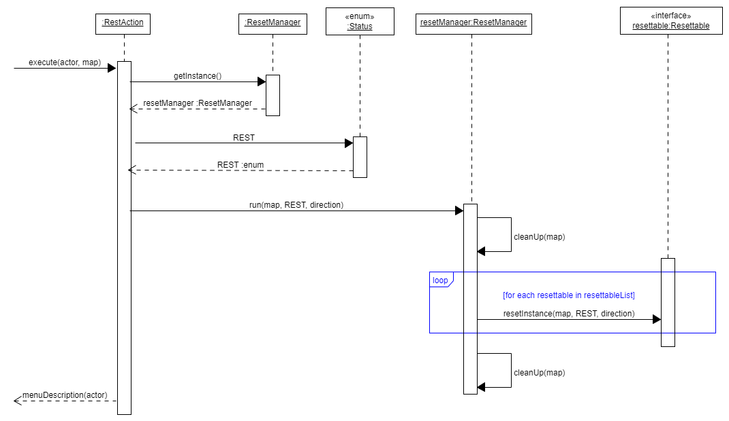

***Sequence diagram - SoftResetAction.execute()***

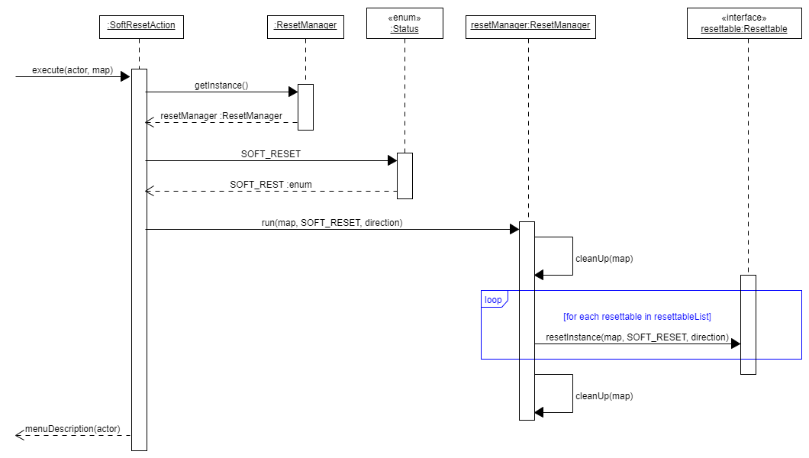

***Sequence diagram - Player.resetInstance()***

